**MS Faculty Bulletin #1**

**Aug 20-24, 2012**

“Therefore, since we have these promises, dear friends, let us purify ourselves from everything that contaminates body and spirit, perfecting holiness out of reverence for God.” [2 Corinthians 7:1](http://www.biblegateway.com/passage/?version=NIV&search=2%20Corinthians%207:1) [NIV](http://www.biblegateway.com/versions/index.php?action=getVersionInfo&vid=31)

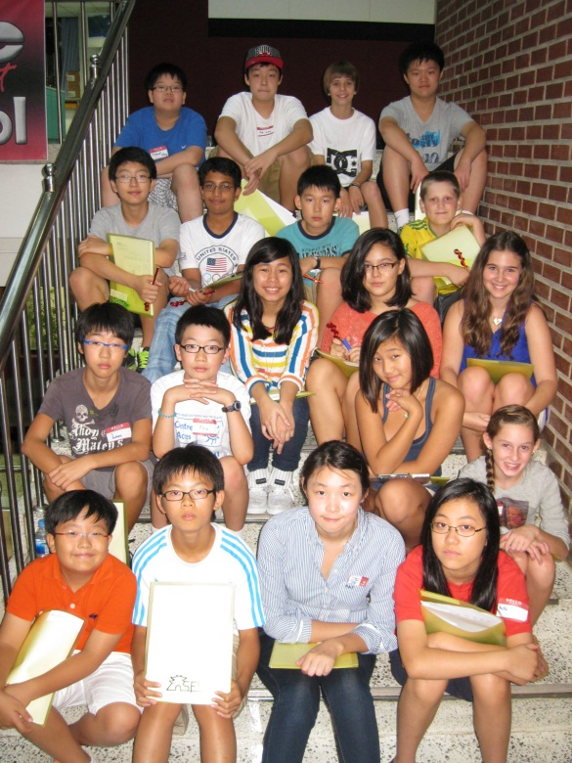

*New Students!*

**///////////////////////////////////**

***Duties this week:***

|  |  |  |  |  |
| --- | --- | --- | --- | --- |
| Dates | Break – MS/BS Basketball Courts  9:45-9:55 | Inside Lunch  Cafeteria  11:32-12:07 | Outside Lunch I  Field  11:38-12:03 | Outside Lunch II  Field  12:03-12:27 |
| Aug 20-24 | Effinger | Jenney | Dunbar | Walker (o), Roddick (e) |

**\\\\\\\\\\\\\\\\\\\\\\\\\\\\\\\\\\\**

***Snacks this week courtesy of****…****Lynn***

***(We have snacks provided by a faculty member (or two) every Wednesday at morning break in the faculty workroom. A sign-up sheet is posted in the workroom. Please sign up to do snacks twice in the year. You may team up with someone to do this!)***

**///////////////////////////////////**

***Meeting Minutes:***

none

**ANNOUNCEMENTS:**

* **Birthdays!** (None this week)
* **Thank you, teachers!** The year is off you a great start! Your professionalism, flexibility, and love for our students already shows. As challenges arise, please let the office team know if there is anything we can do to assist you.
* **New teacher bios**. In case you missed them, [here](https://dl.dropbox.com/u/12440740/Weekly%20Bulletin%20Stuff/Aug%2020-24/bios%202012-13.docx) they are again.
* **Assembly on Tuesday** at 2:10 in Robb Hall – (6th Grade, this hits your Flex time!) The whole point of this assembly is to lay out a menu of extracurricular activities for our students. If you have an activity to promote, let [Jon](mailto:jhill@seoulforeign.org) know by the end of the day on Monday.
* **PowerTeacher and Grade Books** – If anyone still needs help setting these up, please see Jon. Remember, we need to be updating the grade books with something new at least once every two weeks. *(Apology: I completely forgot the second help session planned for last week. If I left anyone hanging, I am so sorry! -Jon)*
* **Portfolio and Conference (PAC) Days** – Every Tuesday or Wednesday in Advisory should be used as a PAC day. Half of the period should be devoted to portfolio work for the class (or extra studies) while the teacher meets with individuals for 5 minutes or so each to discuss their portfolio, goals, and other issues. [Here is a color copy of the form](https://dl.dropbox.com/u/12440740/Weekly%20Bulletin%20Stuff/Aug%2020-24/Portfolio%20and%20Conference%20Record%20Sheet.docx) you can use to guide and record these conferences. [Here is an example](https://dl.dropbox.com/u/12440740/Weekly%20Bulletin%20Stuff/Aug%2020-24/PAC%20Template%20filled%20in.pdf), filled in.
* **Discipleship** – It's not too late to decide you want to be involved as a Discipleship leader. Students leaving SFS often say that Discipleship was one of their most meaningful experiences here. We have plenty of ideas, materials, and expertise to help you if you are worried about what you would do with a group. If we get the overwhelming response we always hope for, we may really need you! Talk to [Bhauna](mailto:bbardolia@seoulforeign.org), [Jean](mailto:jeankim@seoulforeign.org), or [Amos](mailto:alyso@seoulforeign.org) if you have any interest. If you decide to be a leader, Lynn also needs to know by adding your name to her [GoogleDoc](https://docs.google.com/a/seoulforeign.com/document/d/1H08nRnwE1L0eTcA6NjJklAun7BmLLO4DNvNzih8_Rrk/edit).
* **Duty Roster** – There are a couple of minor updates. [Here is the newest version](https://dl.dropbox.com/u/12440740/Weekly%20Bulletin%20Stuff/Aug%2020-24/Duty%20Roster%2012-13.docx). Let Jon know ASAP if there are further conflicts that you can’t solve on your own. Remember, if you decide to swap a week or a day with someone else, let the office team know in advance.
* **MAP Testing soon!** – See the draft schedule below. Please let Jon know if there are glitches or mistakes. It was a little tricky to avoid conflicts with the grade level team building/planning days on Sept 6 and 7, but it should work around those now.



* **Annual Goals** - Annual goals will be an especially important data point this year. In a week or so, Lynn will send annual goal forms your way… You will have 3 goals this  year – the broad school-wide and MS goals will be inserted in the form for you – please elaborate on these so that they are measureable and apply to your needs.   The 3rd goal will be related to your commitment this year to bring balance to your life.  The goal form is due mid-September.  Please email it to Lynn.
* **Edline** – Remind your students to keep their emails in Edline up to date and to accept all emails from the school. They can reach these settings via My Account – > Manage Account. Their email addresses should say "live" next to them to indicate that the email address is verified and working.
* **House and Grade Level Team Assignments**: [**UPDATED CHART**](https://dl.dropbox.com/u/12440740/Weekly%20Bulletin%20Stuff/Aug%2020-24/Houses%20and%20Teams%202012-13.docx)! There have been some last minute changes to house and team assignments. If you are an Advisory teacher, then all of your Advisory students are in the same house as you and will have the same t-shirt color.
* **Students After School** – Most SWEP Activities start on Sept 3. However, there are a few activities/auditions beginning sooner.
  + Jazz band auditions will be Monday and Thursday this coming week (Aug. 20 and Aug. 23);
  + Senate will have 2 meetings the following week as they try to put things in place before discipleship begins – Senate will meet Tues., Aug. 28 and Thurs., Aug. 30.
  + Also on August 30th, we’ll have our first Thursday Intramurals – students can sign up for this at the office window. Girls’ soccer will begin on August 27th.

Any teachers who want to allow students to stay after school for some reason need to use the green passes. See your teacher handbook for more information on the passes. The printed passes are available in the MS Office.

* **Leading By Example** – On most Monday mornings, we recognize a student from each grade level for the leadership and demonstration of our ESLRs or Christ-like attitudes. If you catch a student doing something great, please let the appropriate grade level team leader know! We will have our first Leading by Example certificates given on Monday, August 27th.
* **Advertising your event** – There are a few ways to get the word out! You can email your information to Mrs. Woo for inclusion in the morning announcements. You can also send information or a PowerPoint slide to Jon to be shown on the monitors in the Atrium. The monitors can also display photos or videos of special events that you would like to share.
* **Back To School Night** – is on Sept 5. Email your course syllabus to MS-O by Friday, August 31 so any issues can be ironed out before you show them to the parents.

*Minimum requirements: Course description; major texts used; grading and weighting of components that make up a grade for your course; homework expectations*

* **Professional site of the week**… ISTE – [The International Society for Technology in Education](http://www.iste.org/welcome.aspx)

**MEETINGS and EVENTS this week:**

**Monday, Aug 20:**



**Tuesday, Aug 21:**

* Assembly in Robb hall, 2:10

**Wednesday, Aug 22:**

* SWEP Registration starts for all of SFS
* Team Leader meeting at 3:15

**Thursday, Aug 23:**

* 8:30-10:30 New Parent Coffee in LT

**Friday, Aug 24:**

* G6 GLG in LT

**Coming Up:**

Aug 27 – G7 GLG

Aug 27 – Girls soccer starts

Aug 31 - G8 GLG

Aug 31 – Sept 1 – Faculty Fellowship Weekend at Taechon Beach

Sept 3 – SWEP Activities Begin

Sept 3 – MAP Testing Window Opens

Sept 5 – MS Back to School Night

Sept 6 – Grade 6 team building and planning

Sept 7 – Grade 7 team building and planning

Sept 8 – PTA Ice Cream Social

Sept 10 – Grade 8 team building and planning

Sept 10 – Boys soccer starts, Boys and Girls Cross Country starts

Sept 11 – MS Disciple Kick-off Rally

Sept 10 – G7 GLG

Sept 14 – G8 GLG

Sept 17-21 – Say Something Week

Sept 18 – Noon dismissal of students

Sept 26 – See You At The Pole

Sept 27 – MAP Testing Window Closes

Sept 28 – MS Field Day

Oct 16 - IMPACT

KAIAC Sports Seasons

KAIAC Soccer: Girls: Aug. 27th – Sept. 24th & Boys: Sept. 10th- Oct. 22nd

KAIAC Cross Country: Sept. 10th – Oct. 22nd

KAIAC Swimming: October 29th – December 10th

KAIAC Table Tennis: February 18th- March 18th

KAIAC Volleyball: February 18th – March 15th

KAIAC Basketball: April 1st – May 3rd

*Have a great week!*

-⌡°∩